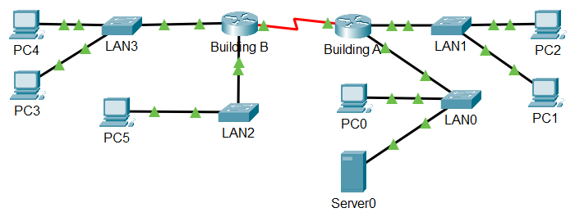

You will subnet the network address 10.51.0.0/13 The network has the following requirements:

* LAN0 LAN will require __100,000_____ host IP addresses
* LAN1 LAN will require ___500_______ host IP addresses
* LAN2 LAN will require ____125,000______ host IP addresses
* LAN3 LAN will require ____10,000____ host IP addresses

## Step 1 - Subnet Table:

Make sure to fill the table from the first IP VLSM block to the last (i.e by size). If the table is not filled in the correct order you may not receive the marks.

|  |  |  |  |  |
| --- | --- | --- | --- | --- |
| Subnet Description | Number of Hosts Needed  *( ## )* | Network Address/CIDR  ( #.#.#.# /# ) | First Usable Host Address  ( #.#.#.# ) | Broadcast Address  (#.#.#.# ) |
| LAN2 | 125000 | 10.48.0.0/15 | 10.48.0.1 | 10.49.255.255 |
| LAN0 | 100000 | 10.50.0.0/15 | 10.50.0.1 | 10.51.255.255 |
| LAN3 | 10000 | 10.52.0.0/18 | 10.52.0.1 | 10.52.63.255 |
| LAN1 | 500 | 10.52.64.0/23 | 10.52.64.1 | 10.52.65.255 |
| WAN | 2 | 10.52.66.0/30 | 10.52.66.1 | 10.52.66.3 |

## Step 2 – Document the Addressing Scheme:

1. Assign the first usable IP address to the router’s interfaces.
   1. For Serial connections assign the first address to s0/0/0 on Router A
2. Assign the last usable IP address to the switch management interface, VLAN1
3. Assign the first available IP address in LAN0 to Server0 (after you have done the above)

|  |  |  |  |  |  |
| --- | --- | --- | --- | --- | --- |
| Device | Interface | Connected To | IP Address  ( #.#.#.# ) | Subnet Mask  ( #.#.#.# ) | Default Gateway  ( #.#.#.# ) |
| Building A Router | G0/0 | LAN0 SW | 10.50.0.1 | 255.254.0.0 | N/A |
| G0/1 | LAN1 SW | 10.52.64.1 | 255.255.254.0 | N/A |
| S0/0/0 | Bld. A R. | 10.52.66.1 | 255.255.255.252 | N/A |
| Building B Router | G0/0 | LAN2 SW | 10.48.0.1 | 255.254.0.0 | N/A |
| G0/1 | LAN3 SW | 10.52.0.1 | 255.255.192.0 | N/A |
| S0/0/0 | Bld. B R. | 10.52.66.2 | 255.255.255.252 | N/A |
| LAN0 Switch | VLAN 1 | N/A | 10.51.255.254 | 255.254.0.0 | 10.50.0.1 |
| LAN1 Switch | VLAN 1 | N/A | 10.52.65.254 | 255.255.254.0 | 10.52.64.1 |
| LAN2 Switch | VLAN 1 | N/A | 10.49.255.254 | 255.254.0.0 | 10.48.0.1 |
| LAN3 Switch | VLAN 1 | N/A | 10.52.63.254 | 255.255.192.0 | 10.52.0.1 |
| Server0 | NIC | LAN0 SW | 10.50.0.2 | 255.254.0.0 | 10.50.0.1 |